

**Automated Scoring for Short Questions with Deep Learning**

Submitted by

Michelle Vanessa

U1620071L

Project Supervisor

Assoc Prof. Hui Siu Cheung

School of Computer Science and Engineering

AY2019/2020



**SCE19-0305**

**Automated Scoring for Short Questions with Deep Learning**

Submitted in Partial Fulfilment of the Requirement for the Degree of Bachelor of Computer Engineering of the Nanyang Technological University

Submitted by

Michelle Vanessa

U1620071L

Project Supervisor

Assoc Prof. Hui Siu Cheung

School of Computer Science and Engineering

AY2019/2020

# Abstract

This report proposes an improved approach of short answer questions scoring with deep learning, namely Siamese Bidirectional LSTM model with feature engineering. The project will conduct several experiments in order to improve the performance of the model. The scope of the questions is limited to Data Structures questions, and Mohler dataset is used in this experiment (Mohler, Bunescu, & Mihalcea, 2011). Eventually, the model will be deployed into a web server for data collection so that the model can be further trained and for self-practice purposes for computer science students.

# Acknowledgements

The author would like to express her gratitude to various individuals for their continuous assistance. This project would not have been possible without their support.

Firstly, the author would like to extend her deepest gratitude to Assoc Prof Hui Siu Cheung, the author’s final year project supervisor, for his guidance, encouragement, and constructive feedbacks throughout the year; to Akhil and Hao Anran for their continuous help and support; and to her parents who have supported her throughout her journey in Nanyang Technological University Singapore. Without them, this project would not have been as successful.

Lastly, the author wish to thank all her friends who have supported during her time in Nanyang Technological University Singapore and have been there for her when she needed encouragement. Without their faith in her, the author would not have been able to complete this project smoothly.

Table of Contents

Abstract 2

Acknowledgements 3

Table of Contents 4

Chapter 1: Introduction 7

1.1 Background 7

1.2 Motivation 7

1.3 Objectives 7

Chapter 2: Literature Review 9

Chapter 3: Past Work 11

3.1 Neural Network Architecture 11

3.1.1 Embedding Layer 11

3.1.2 LSTM Layer 11

3.1.3 Dense Layer 11

3.1.4 Feature Engineering 11

3.1.5 Concatenation Layer 11

3.2 Training 11

3.3 Performance 11

Chapter 4: Experimental Evaluation 12

4.1 Dataset 12

4.2 Evaluation Metrics 12

4.2.1 Pearson Correlation Coefficient 12

4.2.2 Rooted Mean Square Error 12

4.2.3 Mean Absolute Error 12

4.3 Regularization 12

4.3.1 Weight Decay 12

4.3.2 Dropout 12

4.3.3 Batch Normalization 12

4.4 Question Demoting 12

4.5 Classification Model 12

4.6 Experiment Results 12

4.6.1 Regularization Results 12

4.6.2 Question Demoting 12

4.6.3 Classification Results 12

4.7 Analysis 12

Chapter 5: System Implementation 13

5.1 Methodology 13

5.2 System Use Case 13

5.3 Software Architectural Patterns 13

5.3.1 Web Application Framework 13

5.3.2 Database 13

5.3.3 System Interface 13

Chapter 6: Conclusion 14

Reference 15

**No table of figures entries found.**

# Introduction

## Background

One of the main task of an educator is assess the understanding of their students. It can be measured through various assessments, which requires the educator to manually evaluate and grade the students’ responses. Time taken to do such activity depends on the open-endedness assessment since answers of open-ended questions have wider variety and are more subjective. Thus, multiple choice questions will take shorter time to score compared to essay questions. Scoring open-ended questions is susceptible to the grader’s subjectivity since there is no right or wrong. Automated grading system would help speed up scoring process and would be able to objectively grade student responses, thus eliminating the disadvantages of manual human scoring.

## Motivation

The education sector would benefit greatly from the automated essay scoring. Despite the fact that multiple choice questions scoring is now mostly done by machine, automated essay scoring is still not widely used even though it has been a research topic for some time now.

Most educational system still requires human to manually grade them, which consumes a lot of the educators’ time. With the help of the automated essay scoring, the grading process would be shortened (Zhang, 2013), and educators would be able to reduce the time they spend doing so, and hence, increasing educators’ productivity on other activities. Moreover, the automated essay scoring has numerous advantages over manual scoring, such as objectivity and consistency.

* 1. Objectives

The objective of this project is to improve the existing short answer scoring approach, namely the Siamese Bidirectional LSTM model. The approach will be improved by fine-tuning the hyperparameters of the model and modifying the architecture of the model itself. However, the scope of the questions is limited only to Data Structures questions so that the answers could be more topic specific. It would later on be implemented in an educational setting, where it could help facilitate the scoring process of short-answered data structures related C programming questions, which, in this case, is to assist scoring of CX1007 Data Structures course as a part of students’ self-practice and performance evaluation.

# Literature Review

The essay grading problem has been addressed since years ago. One of the earliest approach to the problem is a method known as C-rater (Leacock & Chodorow, 2003), which was developed by Educational Testing Service, also widely known as ETS, to measure students’ understanding based on their responses to short-answer questions. The method compares the syntactical characteristics of a sentence to a collection of correct ones. However, it is ignores the difference between passive and active voice, such as “you need two plants” and “ two plants are needed”.

More recent work has analysed the difference between corpus-based and knowledge-based measures of text similarity, and it was shown using Pearson’s correlation coefficient that corpus-based measure (Lexical Semantic Analysis) performs the best among other measures. It also introduced new technique which is similar to pseudo-relevance feedback to address the problem where there are more than one correct answer (Mohler & Mihalcea, 2009).

Although some works use Pearson’s correlation coefficient to compare student and reference answers, another experiment (Pribadi, Adji, Permanasari, Mulwinda, & Utomo, 2016) showed that similarity measure using Cosine coefficient produce the best result. Cosine similarity measure has the highest accuracy rate compared to other measures, namely Jaccard coefficient and Dice coefficient.

One of the works that use Cosine similarity is the paragraph embeddings (Hassan, Fahmy, & El-Ramly, 2018), which focused on short answer scoring. Answers are considered short “if its length approximately ranges from one phrase to one paragraph”. The word embedding vectors from the answer are combined using average, sum, or other methods, then, using the calculated vectors, new vectors are generated using paragraph embedding model. Cosine coefficient will be use to compare the paragraph vectors.

Another work proposed a new technique named question demoting (Mohler, Bunescu, & Mihalcea, 2011). The technique removes any words that occur in the question from both the student and gold standard answers. This technique is implemented to eliminate the chance that students who repeat words from the question in their answers get high score as it does not reflect their understanding in the topic.

Given the numerous methods, such as text similarity, question demoting, term weighting, length ratio, and word embeddings, some may affect the accuracy more than others. It is proven that alignment has the most significant influence. It measures text semantic similarity using text’s lexical and contextual meaning, which are represented by a word aligner. The rooted mean squared error (RMSE) increased by 5.7% when alignment is removed from the method. On the other hand, question demoting, length ratio, and term weighting improve the RMSE by 1.8%, 0.1%, and 0.2%, respectively (Sultan, Salazar, & Sumner, 2016).

For longer answers, Gated Convolutional Networks approach is more suitable. An experiment on a whole paragraph has shown that the approach is superior to long short term memory (LSTM) method. It requires less computational time (2 weeks training on 8 GPUs) as the networks can be “stacked” into hierarchical structure and operations can be executed in parallel (Dauphin, Fan, Auli, & Grangier, 2017).

# Existing Approach

This chapter discusses the machine learning techniques used in the existing approach.

* 1. Neural Network Architecture

Figure 1 is the neural network graph of the model as generated by the visualisation tool, TensorBoard. The individual units of this graph will be discussed further in the following sections.

Figure 1 Neural network graph generated by TensorBoard

As shown in the figure above, the approach implements neural network, which consists of several layers. Figure 2 is the illustration of the layers in the network.

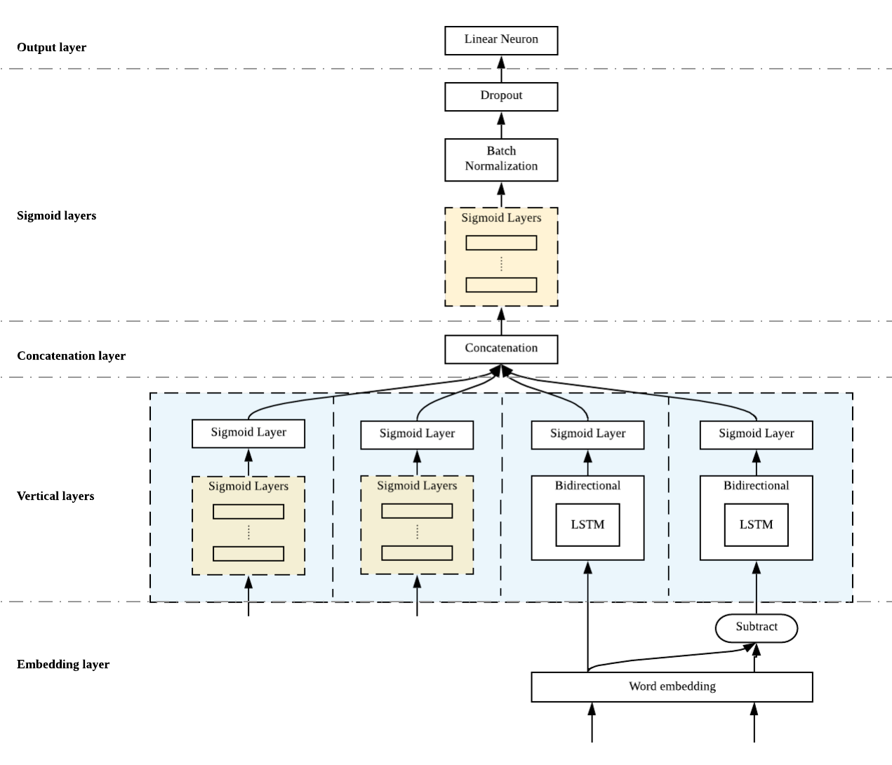

Figure 2 Network architecture illustration

* + 1. Embedding Layer

The first layer of the network is the embedding layer. This layer takes in a sequence of words as input, and each word will be mapped into high-dimensional vectors representing the respective words, also known as word embedding. In word embedding, similar words have similar values, and vector operations can be performed to obtain other words’ vector values.

This approach uses Word2Vec, which is one of the word embedding models. The model utilises the Skip-gram model and negative sampling (Goldberg & Levy, 2014). The words are represented in such a way that the result of the vector operations reflects the linguistic patterns of the words. For example, the operation of the vectors “Madrid” – “Spain” + “France” will result a vector close to the vector of “Paris” (Mikolov, Sutskever, Chen, Corrado, & Dean, 2013).

The input of this layer will be the student answers and the reference answers, which will be the gold standard during the training of the model. On the other hand, the output of this layer will be the mapped word vectors of the respective answers.

* + 1. Vertical Layers

This layer consists of several vertical layers that is independent from each other, and each has its specific functions.

* + - 1. Leaks
      2. Feature engineering

This layer takes input of 5 set of data obtained from feature engineering. Feature engineering is a process where a certain data is produced by transforming raw data so that it could be used by the model to better learn the pattern of the given data (Casari & Zheng, 2018). In this case, length of the student answer (number of characters), ratio of the length of the reference answer and length of the student answer, number of words in the student answer, and the number of unique words in the student answer are used.

The input is then processed through 5 layers of 125 neurons with sigmoid activation function.

* + - 1. Student answer
      2. Answer comparison
    1. Concatenation Layers
    2. Sigmoid Layers
    3. Output Layer
  1. Implementation
  2. Training
  3. Performance

# Experimental Evaluation

* 1. Dataset

The experimental evaluation uses a dataset from an experiment conducted by Mohler, Bunescu, and Mihalcea (Mohler, Bunescu, & Mihalcea, 2011). The dataset consist of short-answered data structures questions.

* 1. Evaluation Metrics
     1. Pearson Correlation Coefficient
     2. Rooted Mean Square Error
     3. Mean Absolute Error
  2. Regularization
     1. Weight Decay
     2. Dropout
     3. Batch Normalization
  3. Question Demoting
  4. Classification Model
  5. Experiment Results
     1. Regularization Results
     2. Question Demoting
     3. Classification Results
  6. Analysis

1. System Implementation
   1. Methodology
   2. System Use Case
   3. Software Architectural Patterns
      1. Web Application Framework
      2. Database
      3. System Interface

# Conclusion

# Reference

Zhang, M. (2013). Contrasting Automated and Human Scoring of Essays. In *R&D Connection* (Vol. 21, pp. 1-11). Princeton, NJ: Research & Development Educational Testing Service.

Leacock, C., & Chodorow, M. (2003). C-rater: Automated Scoring of Short Answer Questions. *Computer and Humanities, 37*, 389-405.

Mohler, M., & Mihalcea, R. (2009). Text-to-text Semantic Similarity for Automatic Short Answer Grading. *Proceedings of the 12th Conference of the European Chapter of the ACL* (pp. 567-575). Athens, Greece: Association for Computational Linguistics.

Mohler, M., Bunescu, R., & Mihalcea, R. (2011). Learning to Grade Short Answer Questions using Semantic Similarity Measures and Dependency Graph Alignments. *Proceedings of the 49th Annual Meeting of the Association for Computational Linguistics* (pp. 19-24). Protland, Oregon: Association for Computational Linguistics.

Pribadi, F. S., Adji, T. B., Permanasari, A. E., Mulwinda, A., & Utomo, A. B. (2016). Automatic Short Answer Scoring Using Words Overlapping Methods. *Engineering International Conference.* AIP Publishing.

Hassan, S., Fahmy, A. A., & El-Ramly, M. (2018). Automatic Short Answer Scoring based on Paragraph Embeddings. *International Journal of Advanced Computer Science and Applications, 9*(10), 397-402.

Sultan, M. A., Salazar, C., & Sumner, T. (2016). Fast and Easy Short Answer Grading with High Accuracy. *Proceedings of NAACL-HLT* (pp. 1070-1075). San Diego, California: Association for Computational Linguistics.

Dauphin, Y. N., Fan, A., Auli, M., & Grangier, D. (2017). Language Modeling with Gated Convolutional Networks. *Proceedings of the 34th International Conference on Machine Learning.* Sydney, Australia.

Mikolov, T., Sutskever, I., Chen, K., Corrado, G., & Dean, J. (2013). Distributed Representations of Words and Phrases and their Compositionality. *Advances in Neural Information Processing Systems 26*.